
Characterization of walnut hybrid plus trees for good quality wood plantations.

Ignacio Urbán¹, Ricardo Licea¹, César González², Fernando Villar de Arcos² , Óscar Santaclara³, and Esther Merlo³

¹ Forestry Department
Bosques Naturales S.A
Alcobendas, Madrid, 28108, Spain
²Plant production Department
Escuela Técnica Agrícola
Madrid, Madrid, 28040, Spain
³Wood quality Department
Madera Plus S.L.
Orense, Galicia, 32901, Spain

Abstract
There is an increasing interest for broadleaf plantations destined to good-quality wood production. This search for new productive alternatives that bring a higher profitability is directly related to the growth of this type of plantations. The Juglans tree is one of the species that in the last years has been widely planted in Southern
Europe for this purpose. To be able to have plantations destined to hardwood production that can be transformed by industry into a profitable way, there are three factors needed: a good quality station, a good adapted vegetative material and the application of a suitable forestry management during its development. The present piece of work is focused on the characterization of plus trees coming from seeds of walnut hybrid managed by the company Bosques Naturales, S.A. These plantations are located in three different edaphoclimatic areas in the Iberian Peninsula (Navarra, Cáceres and Gerona). We have characterized a total of 38 plus trees of 13 years old, by adding to the growth and tree shape data the information obtained referred to wood quality, phenological tracing and molecular markers used. Different data are displayed from each research area as well as the interrelationship between them. This information is being used for held trials by using the best clones that have been reproduced by the in vitro technique.
1. Introduction
The use of European broadleaves is being promoted from several scientific and European cooperation programs (ActionCOST E42: 2004-2008; Treebreedex), as well as with public incentives for the establishment of noble hardwood plantations. Due to its multiple benefits, including high-priced wood, the walnut tree has aroused the interest of forest owners in both sides of the Atlantic Ocean (Hemery et al. 2008).
In Spain walnut plantations for wood production have been recently implanted.The oldest are around 15 years old and were typically established on good forestry and agriculture lands. The management is intensive in order to meet two productive objectives: a) shorten rotation by speeding the growth, and b) obtain good quality wood, defined as the one with few defects and regular growths.
The company Bosques Naturales S.A. has as its main activity the establishment and maintenance of hardwood forestry plantations, based mainly in the species: cherry tree (Prunus avium) and hybrid walnut (Juglans major var. 209x Juglans regia). It manages more than 1,300 ha in Spain.
With hybrid walnut between 2002 and 2008, the company has been doing a continuous work of identification and selection in production areas with seed species of those individuals which had more prominent timber features. In some cases, these individuals have become head of families from which clonal descendants have been obtained; in other cases these individuals are kept in study for further consideration as selected trees or to be definitely discarded.
The company currently manages more than 40 hectares of clonal hybrid walnut with less than 10 years old from this early selection and so far with very good results with the move to clonal plantations the forecasted improvement is of 20% in volume and 25% on the number of trees per hectare of high wood quality (Murillo and Badilla 2006).
With the purpose of completing the selection program for the period 2008 to 2012, the company introduced two new lines of work, aside from growth, shape and phenology:
- Wood quality definition (using non-destructive methods): Wood quality criteria can only been applied to specify the purpose to which the wood is used. However, some of the general requirements for wood quality can be applied for multiple purposes. The main objective is to increase the knowledge of tree growth in hardwood species, paying special attention to valuable wood production and with the intention of promoting other wood products that can be produced together with the main product (good quality veneer) genetic control of the wood variables has been widely studied and shown for conifers, but when we get to hardwoods, the number of studies drops dramatically.
- Use of molecular markers (SSRs): 1) Generally they have a high polymorphism in the length, which is easily detected with appropriate methods and instrumentation. 2) They have a very high relative abundance and are distributed evenly throughout the genome. In other words, they have a very high potential for genetic improvement. 3) The degree of specificity at the locus is large in general and this is because those microsatellites are usually flanked by unique sequences, thus facilitating the development of specific amplification primers for PCR. 4) It is not uncommon that the primers developed for one species, can be transferred to other, especially if they are far apart phylogenetically. 5) Further microsatellite markers are co-dominant, that is, are easily differentiated allelic variants of both parents, if any, all of which facilitates the identification and establishment of relationships among individuals. The reproducibility of microsatellites is such that, they can be used efficiently by different research laboratories to produce consistent data (Agarwal 2008).
2. Material and Methods
2.1. Vegetal material
The selected material comes from the plantations the company Bosques Naturales S.A.owns in Gerona, Cáceres and Navarra. (Table 1). The origin of the vegetative material is the progeny seed Mj209xRa, acquired in the South of France.

Table 1: Characteristics of the plantations.
Forest Management Unit | Gerona | Cáceres | Navarra
Coordinates | lat. 42º 9' 55'' N  long. 2º 56' 37'' E | lat. 40º 6' 54'' N  long. 5º 20' 32'' W | lat. 42º 10' 10'' N long. 1º 39' 9'' W
Altitude | 45m | 350m | 250m
Mean annual temperature | 14,7ºC | 14,1ºC | 13,8ºC
Total annual precipitation | 857mm | 844mm | 416mm
Type of management | Intensive (fertirrigation) | Intensive (fertirrigation) | Extensive
Spacing | 6m by 5m | 6m by 5m | 1m by 1m
Age at sampling | 12 years | 13 years | 11 years
Number of seed plantation | 22105 genotypes | 33283 genotypes | 5007 genotypes

No Persian walnut timber (Juglans regia) selections were available when the company started the plantations. On the other hand the French hybrid progenies, Mj209xRA were outstanding for their vigor and growth habit (Aletà et al. 2003).
The Mj209xRA progeny was initially considered a J. nigra to be later classified as a J. major. Currently we tend to think that the female progenitor (parental) is itself a hybrid but with a productive capacity. The greater heterogeneity observed in this progeny descendants it is explained as they do not correspond to a real F1 (first filial generation). It is one of the most planted progenies in Spain, and it is demonstrating to be highly adaptable to alkaline soil areas and warm areas of the Iberian Peninsula (Aletà et al. 2006).
Seed plantations to make elite material selection are aged 11, 12 and 13.In the case of other Juglans sp. programs, the minimum age indicated for early selection is at least 10 years (Wright 1966) although it is probably best to select from 15 years or more. (Rink and Clausen 1989, Bresnan et al. 1992).
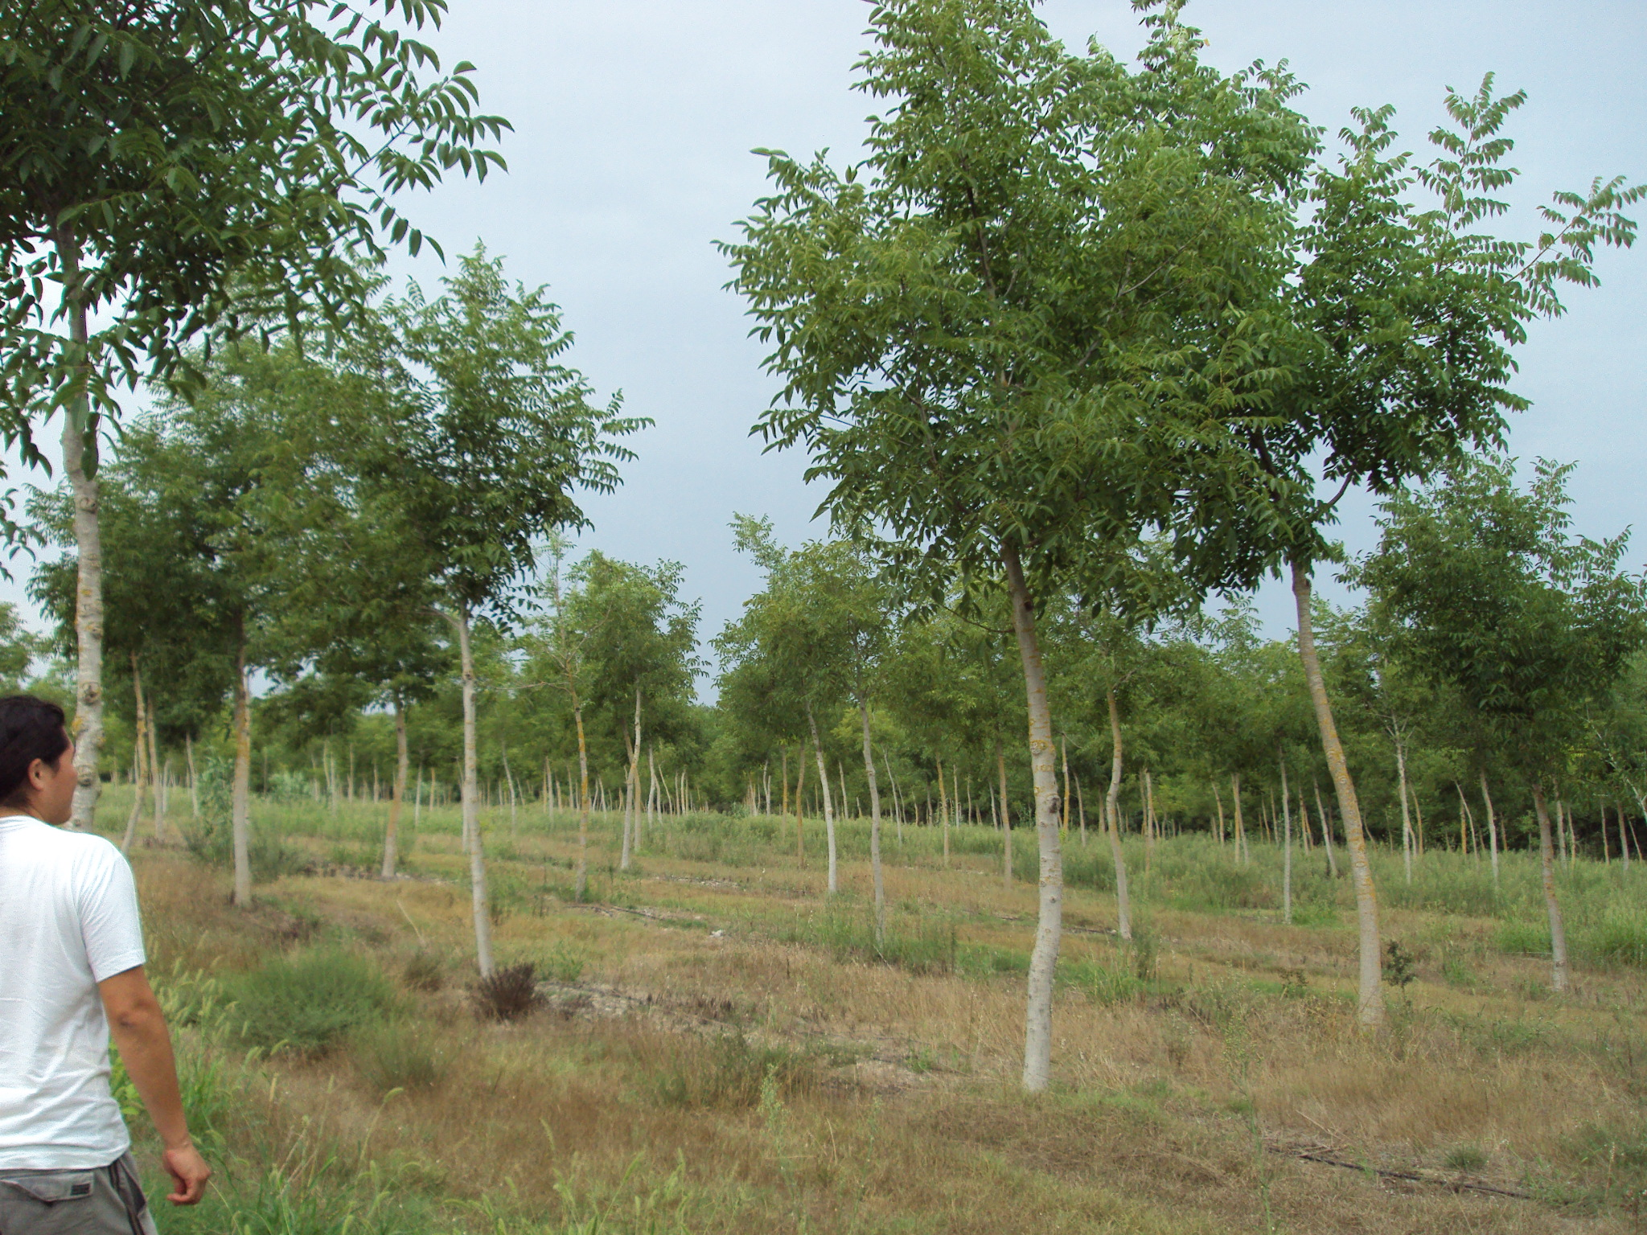
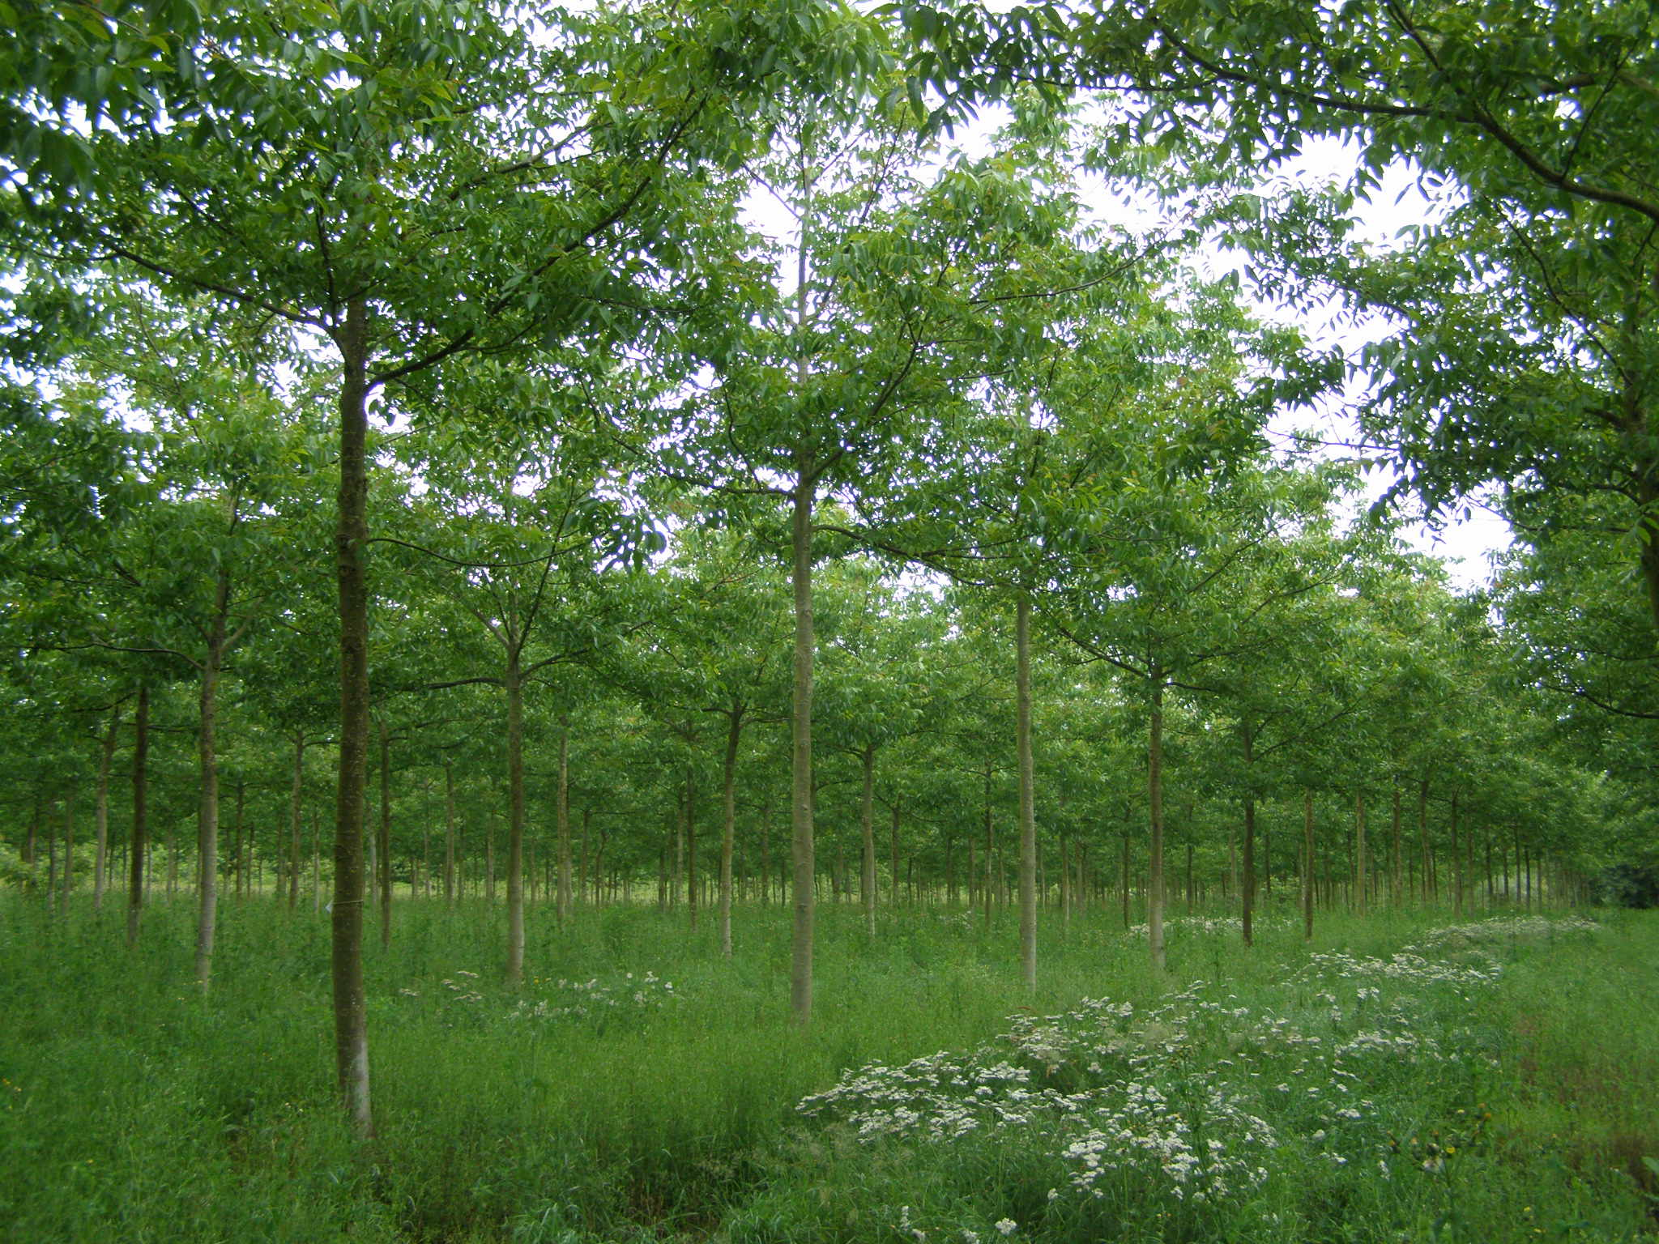

Figure 1. Difference between two walnut plantations aged eight years.
Left seed origin, right conal origin (produced by tissue culture).

2.2. Analyzed variables
2.2.1. Forest mensuration and stem shape
The superior trees were selected based on a check tree comparison method (dominant trees were marked as check trees or comparison trees which surround and are in the vicinity of the superior tree). The selection procedure involves measurement of total height, diameter at breast height (DBH), clear bole height and stem shape (straight and cylindrical bole) (Figure 2), and free from pest attack and disease.
These plus trees are localized by GPS and marked with a label for its further localization.
The selected tree is compared with the dasometry measurement data from the stand which is the average of established population on the same soil type and of the same age.
Tree shape and curvature based on the next classification (MacDonald et al. 2001).
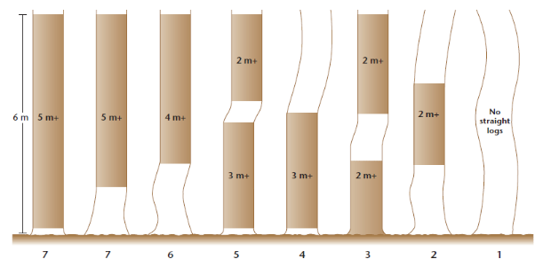
Figure 2 Straightness score: Different combinations of log lengths in first 6 m
showing gradual reduction in quality from left to right.
2.2.2. Wood quality
Intrinsic wood variables will determine the physical-mechanical and esthetical characteristics as well as wood homogeneity inside the stem. It is widely accepted that among physical features, density is universally used as a wood quality attribute regarding their uses. Besides, density is correlated with most physical-mechanical properties (Barnett and Jeronimidis, 2003). The non-destructive testing methods, NDT, can be defined as techniques that allow examining the material without affecting its properties, integrity and final use.
To calculate the densitometry RX, an extraction was performed at 50 cm from the base of the trunk of a wooden core containing the bone, using a Pressler auger. The cores were stored in controlled conditions and then subjected to direct assessment RX following the methodology of Polge (1963). Later analysis was performed with the software radiographs WinDendro. Density data were collected every 0.0254 mm along the length of the core.
2.2.3. Phenology
A large group of characters used for the description of the material is related to the phenology control of each of the individuals under study.
By direct field observation during the visits to the different plantations, and based on phenology descriptors for these species and other reference data (Vázquez de Prada 1978); the timing of the main phenological stages in the vegetative cycle was recorded.
See for this stages taken into account. 1) Swollen buds: All vegetative buds are in white or woolly button. 2) Sprouting: All vegetative buds are open with their scales separated. 3) Visible sprout: The first leaves sprouts begin to loosen 4) Leaves separation: On the vegetative sprouts leaf primordia are completely separated 5) 1st leaflet formed: On the sprouts the first leaflet is completely formed 6) Leaf completed: Sprouts have, at least, one complete leaf. 7) Leaf completed: All of the leaves have reached their typical varietal full size.

2.2.4. Molecular markers
In order to characterize the microsatellite genotype, the genetic profile of 39 plus trees was created with a set of ten highly polymorphic SSR markers (table 3) developed specifically for our hybrid walnut population (Contreras et al. unpublished) plus two for genotyping J. nigra (Woeste et al. 2002) and J. cinerea (Ross-Davis et al. 2008). A DNeasy Plant Mini Kit (Qiagen) was used for genomic DNA extraction. PCR conditions were: one step 94ºC during 1´; 30 cycle of 94ºC 30´´; 30´´ of annealing temperature (table 3) and 72ºC during 30´´; finally an extension step during 45´´ of 60ºC. 5 ng of DNA was used as template. Primers were marked before the amplifications and PCRs products were analyzed by fluorescence, which increased the sensibility for detection of amplified regions. Electropherograms obtained with program Peak Scanner v. 1.0 (Applied Biosystems) were used to assign allelic sizes per locus.
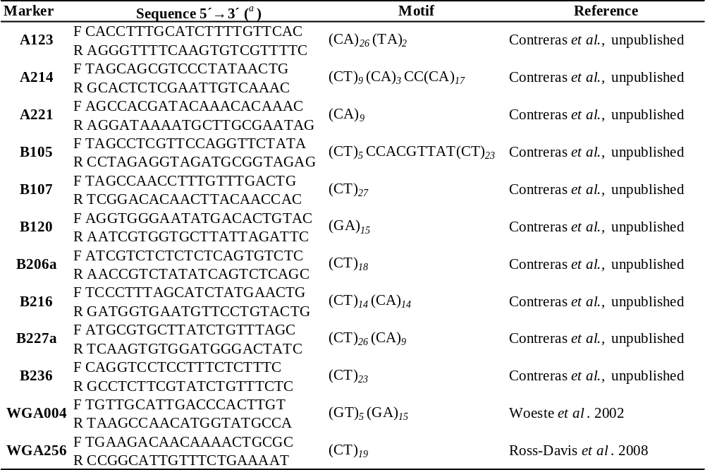
Table 2. Molecular markers (primer pairs) used for genotyping selected trees.

3. Ressults and Discussion
3.1 Forest mensuration and stem shape
The selected tree height varies from 13 to 20 meters. The average increase of the normal diameter varies from 2.6 cm to 1.3 cm.
However, it is noteworthy that in this type of plantations it is very important that trees to have a cylindrical and straight shape suitable for veneer production, so only the trees with a minimum grade of 4 according to Table 2 are selected.
The values obtained from monitoring the selected trees are shown in table 3.
Table 3. Dasometry and stem shape results. (st. dev.)
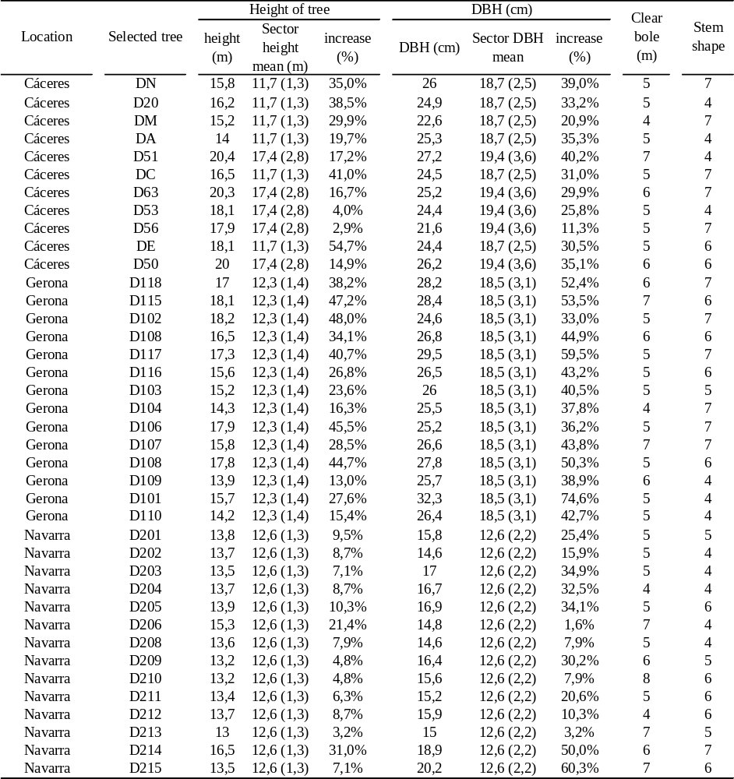
3.2. Wood quality
There was a great variability in the values of average density per ring of the different trees sampled (Figure 3), largely explained by the environment. The average density values obtained by ring fit the technological requirements for obtaining wood veneer. These values obtained are consistent with those obtained in a preliminary study to characterize timber using destructive methods in the same company intensive plantations (Merlo et al. 2009). The results support what we already pointed (Alèta and Vilanova 2006) regarding the possibility of obtaining, on walnut hybrid clones (Mj209xRa) and rotations close to 30 years, a wood comparable in physical qualities, that of the walnut trees that currently marketed: J. nigra from U.S. and J. regia from various countries in Eastern Europe and Central Asia.
The same was observed for cherry clones on two different locations (Nocetti et al. 2010) and coincides with that observed in other species such as poplar leafy (Pliura et al. 2005). This variation was independent of the width of ring and separately for each clone.
There was no direct relationship between the width of the ring with the density, which enables a joint selection of variables and supports both intensively managed with high growth to shorten the rotation age without negative influence on wood density.
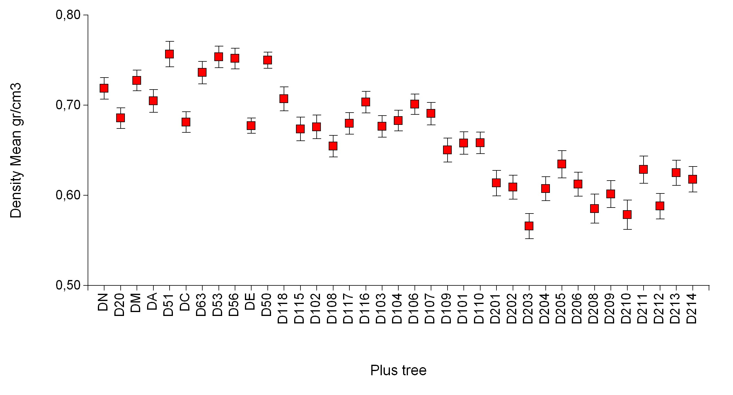

Figure 3. Mean ring density value in all selected trees. (Bars indicate standard error).
The value of walnut timber (Juglans sp.) is affected by the quality and quantity of darkly-colored heartwood in its stem (Woeste 2002). Not all selected trees have started heartwood formation. The following figure shows the values we obtained when measured on core removed.
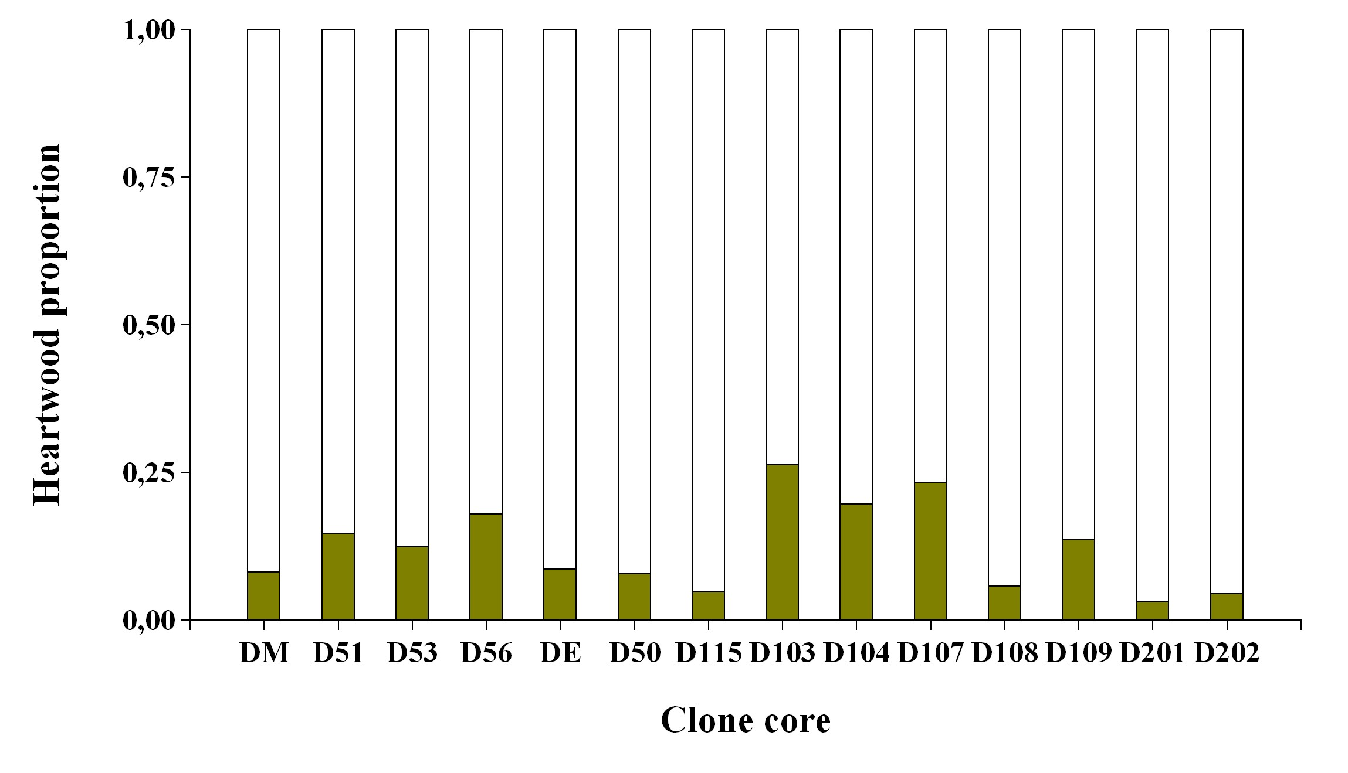

Figure 4. Proportion of the total heartwood of the core extracted
3.3. Phenology
For phenologic characterization it has been used phenograms in which it can be seen the different periods time used by the selected walnut trees, from Cáceres, Gerona and Navarre between phenological stages.
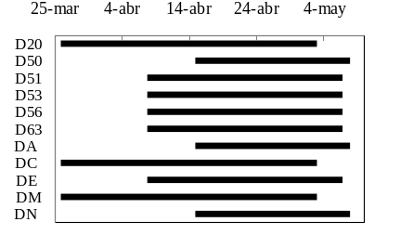
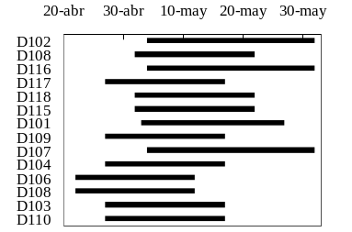
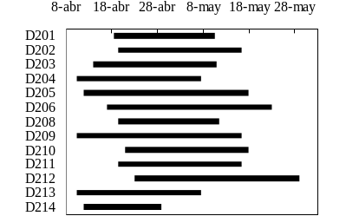
In hybrid walnut tree phenological periods is set since the vegetative buds are opened with separated scales, until the sprouts have, at least, one full leaf (figure 5).
FMU Cáceres
FMU Gerona
FMU Navarra
Figure5.Phenogram made from data obtained in the phenological control
3.4. Molecular markers
The results obtained for each SRRs presented, opens the possibility of using molecular markers in advanced program attendance improvement genetic. The generation of Juglans Mj209xRA fingerprints can be extended to the other collections of clones and used as a protective mechanism of the genetic.
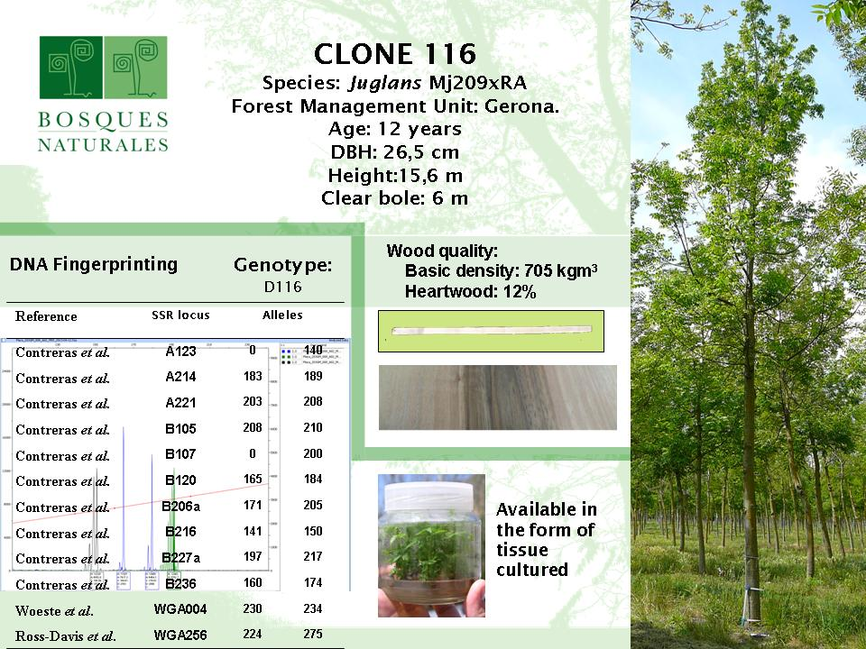

Figure 6. Example of technical details of business information, application of
molecular markers in defining fingerprints.

4. Conclusions
Currently Bosques Naturales S.A. plantations are in a good development situation time, in order to make tree selection. There are trees growing conditions and interesting ways of improving the productivity of wood quality in walnut plantations.
The non-destructive methods have proven to be a useful technique for the evolution in wood quality for plus trees without being necessary it’s felling. It is necessary to continue in the knowledge of heartwood formation timber feature significant difference for this variable has a very high economic impact so it is very interesting to study clonal plantations.
The characterization of elite plant material is needed for possible future protection complying with the conditions of novelty, uniformity and stability. The description of materials at the morphological and phenological currently can be completed with the use of molecular markers. In the future it will be interesting to advance their possible use in early breeding programs.
It is necessary the implementation of clone essays trials in different environments and with different forestry management in order to know the real potential of these materials.

Acknowledgements
The authors wish to thank Bosques Naturales S.A. staff and this work was made in the project financed by CDTI IDI 20100444.

Literature Cited
Agarwal, M., N.Shrivastava, and Padh, H. 2008. Advances in molecular marker techniques and their applications in plant science. Plant cell Rep, 27:617-631.
Aletà, N., A. Ninot, and J.Voltas. 2003. Caracterización de 12 genotipos de nogal de Juglans spp en dos localidades de Cataluña. Investigación Agraria: Sistemas Agroforestales 12 (1): 29-50.
Aletà, N. and A. Vilanova, 2006. El nogal híbrido. Navarra Forestal nº 13: 18-21.
Barnet, J. R..G. Jeronimidis.2003. Wood Quality and its biological basis. CRC Press, 226. ISSN 0735-6161.
Bresnan, D., W.A.Geyer,K.D. Lynch, G.Rink. 1992. Black walnut provenance performance in Kansas. Northern Journal of Applied Forestry. 9: 41-43.
Contreras, A., L. Gómez. Unpublished. Development and characterization of microsatellite markers in Juglans major var. 209 x J. regia.
Hemery, G., H. Spieker, E. Aldinger, K. Gary, C. Collet, and S. Bells. 2008. COST Action E42. Growing valuable broadleaved tree species. Final Report. http://www.valbro.uni-freiburg.de/pdf/COST_E42_Final_Report_2008.pdf
Macdonald, E., S. Mochan S. and T. Connolly. 2001. Protocol for Stem Straightness Assessment in Sitka Spruce. Information Note. Forestry Comission 231 Corstorphine Road. Edinburgh. EH12 7AT. http://www.forestry.gov.uk
Merlo E., O. Santaclara, and I. Urbán. 2009. Uso de técnicas de ensayo no destructivas para el conocimiento de la calidad de la madera de las plantaciones de nogal (Juglans Mj209xRa) y cerezo (Prunus avium) propiedad de Bosques Naturales S. A. Ref 5CFE01-644. 5º CFE. Editores: SECF.-Junta de Castilla y León. Avila.2009 ISBN: 978-84-936854-6-1.
Murillo, O. and Y. Badilla. 2005. ¿Qué es mejoramiento genético forestal?. Manual. Taller de Publicaciones del Instituto Tecnológico de Costa Rica. Escuela de Ingeniería Forestal. Cartago, Costa Rica. 14 p.
Nocetti, M., M. Brunetti, F. Ducci, M. Romagnoli, F. Santi. 2010. Variability of wood properties in two wild cherry clonal trials Wood Sci Technol 44:621–637 DOI 10.1007/s00226-009-0294-x.
Pliura A., Q. Yu, S.Y. Zhang, J. Mackay, P. Perinet, J. Bousquet. 2005. Variation in wood density and shrinkage and their relationship to growth of selected young poplar hybrid crosses. Forest Science 51 (5), 472-482.
Polge, H. 1963. Une nouvelle méthode de détermination de la texture du bois: lʼanalyse densitométrique de clichés radiographiques. Ann. Sci. Forest. 20: 533–580.
Rink,G, K.E. Clausen. 1989. Site and age effects on genotypic control of juvenile Juglans nigra L. tree height. Silvae Genetica. 38 (1): 17-21.
Ross-Davis, A., and K. Woeste. 2008. Microsatellite markers for Juglans cinerea L. and their utility in other Juglandaceae species. Conserv. Genet. DOI 10.1007/s10592-007-9337-8.
Vázquez-Prada M., 1978.. Fenología: estados-tipo en diferentes especies frutales. Escuela Técnica Superior de Ingenieros Agrónomos. Madrid. 41p.
Woeste, K., R. Burns, O. Rhodes, and C. Michler. 2002. Thirty polymorphic nuclear microsatellite loci from black walnut. J Heredity 93: 58–60.
Woeste, K. 2002. Heartwood production in a 35-year-old black walnut progeny test. Can. J. For. Res. 32: 177-181.

*Corresponding author Tel.: (0034) 636974148; E-mail: ignaciourban@bosquesnaturales.com

